Problem-1

**SYED GHASSAN FAHEEM**

**15l-4375**

**Section B**

**Digital image processing**

Area Fill

In this section, Area is filled by the connected pixels in an image by C program. C subroutine to find all the pixels connected to s0 is implemented in this region.

Plot image im22gd2.tif

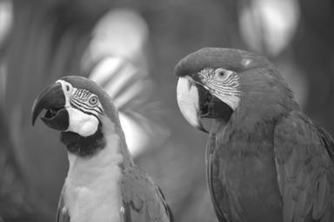

Figure 1: Original img22gd2.tif

**1**

The following is the image of connected set for S= (64;45) and T(threshold) T=2

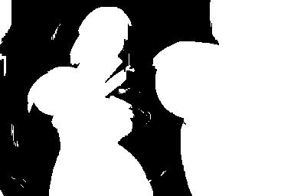

Figure 2: s = (67; 45), and T = 2

**2**

Image Segmentation

In this section, instead of using only one pixel to grow the connected sets, we index through the image to extract all the connected sets in the original image. Hence, an image segmentation is performed in this section.

Plot image segmentation for T = 2

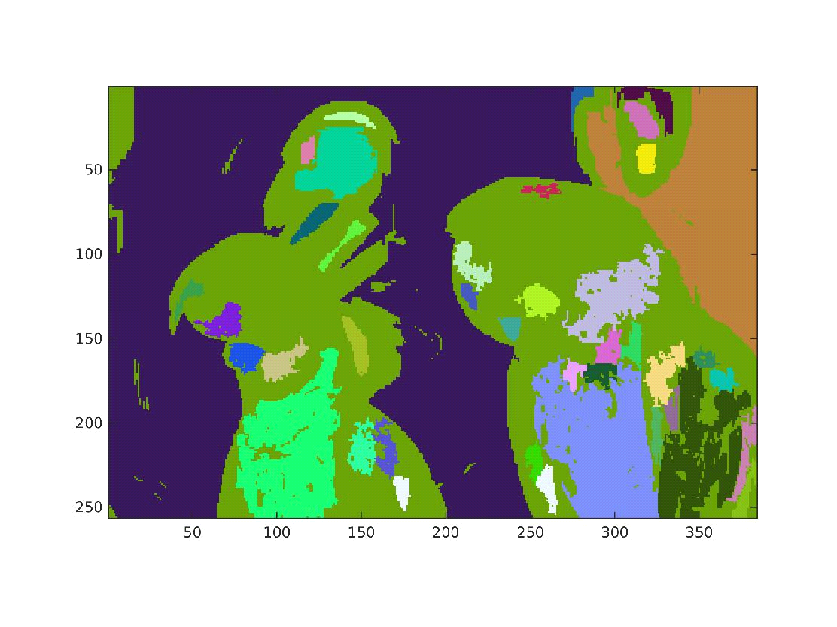

Figure 3: Randomly colored segmentation for T = 2

**3**

The number of regions in this segmentation at T=2 is **41**